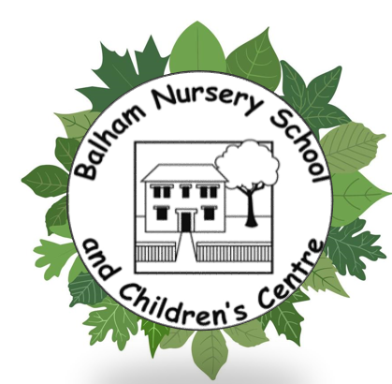
Balham Nursery School
Early Years Pupil Premium
Since April 2015, nurseries, schools, childminders and other childcare providers have been able to claim extra funding through the Early Years Pupil Premium to support children’s development, learning and care.
National data research tells that children eligible for free school meals tend to do less well, than other children. The Early Years Pupil Premium is to provide us with extra funding to close this gap.
We are required to publish details of:
- Our pupil premium allocation for the current academic year.
- Details of how we intend to spend our allocation.
- Details of how we spent our previous academic year’s allocation (when applicable).
- The difference to the attainment of disadvantaged pupils the funding has made.
A child will be eligible for the EYPP if they:
- Are in a low-income family and their parents are in receipt of benefits (one or more), for example, Child Tax Credit and Income Support; Income-based Jobseeker's Allowance, Working Tax Credit, Universal Credit (with an annual net earned income up to £7,400), support under part six of the Immigration and Asylum Act 1999, etc
- Have been adopted from care;
- Have left care through special guardianship;
- Have been looked after by the local authority for at least the span of one day;
- Are subject to a child arrangement order.
The Early Years Pupil Premium provides an extra 68 pence per hour (April 2024) for three and four year old children attracting entitlement funding. This now means an extra £387 a year for each child taking up the full 570 hours funded entitlement (15 hours per week) of early education. This additional money makes a significant difference to us. We are in receipt of £2162 for the academic year 2024-2025.
Barriers for future attainment (for children eligible for Early Years Pupil Premium)
Barriers to learning for many children eligible for EYPP at Balham, were linked to circumstances in the home impacting on children’s emotional wellbeing; social skills: poor social interaction; low confidence and anxiety around attachment, as well as, difficulty following adult direction and boundaries. Speech and language delay was a factor for some of the children. Poor attendance was also a barrier to learning.
We can use the extra funding in any way we choose to improve the quality of the early years education that we provide for your child. This year we have noticed the following avenues is in need of further support and development, and we will use it to fund the following;
- Provide small group work music sessions, supporting listening and attention, social confidence and social interaction.
- Providing additional staff when needed to allow us to enhance our child: adult ratios.
- Purchasing additional resources.
- Many children have speech and language difficulties, so we will spend some of the EYPP funding to support and further develop children's language.
- Fund and /or subsidise our school trips and offer first hand experiences for our children (e.g. life cycle
- duckling, chicks, butterflies) Museum visits, local and wider community trips, etc.)
- Cover the cost of a school meal for those not eligible for a FSM
- Cover the cost of an additional session to support a family in need.
- We will focus on early maths and literacy for our 2, 3 and 4 year olds, where there are gaps in their knowledge.
- We have also noticed that some of our children miss opportunities to take part in physical activities, particularly outdoors, so this is another area that we want to develop, and which our large garden enables so well.
- Other things we are using our EYPP money for is building relationships and engagement with parents and carers in our social and curriculum workshops.

It is well documented that high quality early education can influence how well a child does at both primary and secondary school, so we do want to make the most of this additional funding. You may be aware, if you have older children that pupil premium has been available in school age children and it has proved to have given a real boost to the children receiving the funding. We want to do the same for our early years children entitled to this funding.
A return is submitted to the local authority for eligibility to be checked, we receive the results approximately a month following submission. This enables us to confirm the children within the setting who are eligible.

The number of children eligible varies each term, according to movement within the nursery, transitioning out and transitioning in. Last year our Early Years Pupil Premium allocation was £2162. During the academic year, from September 2024 we noted that there were 6 children eligible for EYPP.
As an Early Years setting, we have the freedom to choose how we spend the money to best support specific children in our care.
In the past this funding has also been used to support children and their families in various ways.
Measuring the impact of the EYPP
We are continually reviewing the data we collect on children’s attainment and refreshing our strategies to support children who are falling behind or in danger of doing so. The practical ideas that are implemented on a daily basis are only a few of the strategies used and their success can be monitored through the data. However, there are other ways that we measure and monitor the impact we have on families. These are:
- Parent questionnaires
- Informal conversations at the start or end of a day
- Parent feedback through exit interviews
- Parent/teacher conferences
- Success after the implementation of any Early Help support within the school and through referrals to other partner agencies.
- Conversations with professionals we work alongside to support families
- Feedback from feeder primary schools
- Case studies

